**using explanation**

1. Executing <Server.exe> in folder <Exe\1. Server x64 >

Executing <Client.exe> in folder < Exe\2. Client x64 >

Or run the source code. (Server must be execute first, otherwise client will off because fail to connect to the port)

Before executing, Default working directories must be set (See the txt in the folder).

1. If the connection is successful, you will see the following screen:

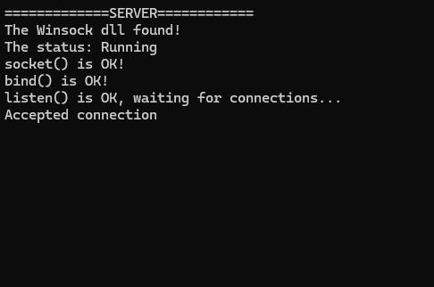

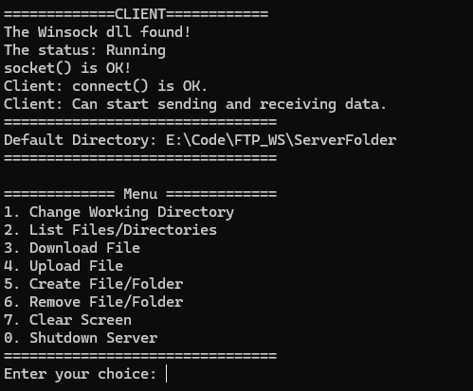

1. You can use the commands in the menu, input the number before the commands and just follow the hint.

Examples:

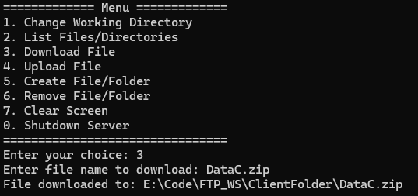

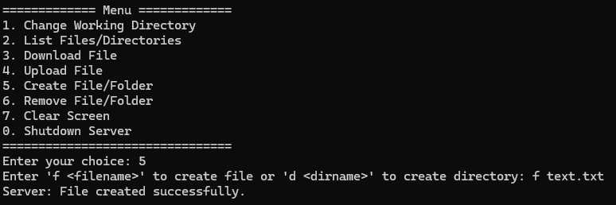

Warming: list an empty directory is invalid.